**Emission Control Systems**

**Introduction**

In the previous discussion, we studied the negative effects of the emissions on the environment and humans. Therefore, we need to minimize the portions of these emissions to the atmosphere to a minimum value. This can be achieved by means of emission control systems. The control systems currently available in modern internal combustion engines:

- Secondary air injection   
- Exhaust gas recirculation (EGR)  
- Catalytic converter

In the following discussion, we will handle the EGR emission control system very closely and understand its contribution to emission control, the system's parts and how to control it.

**Exhaust Gas Recirculation (EGR)**

As we have learnt, NOx is formed in the combustion chamber of engines, when high temperatures cause oxygen and nitrogen (both found in the air supplied for combustion) to combine.

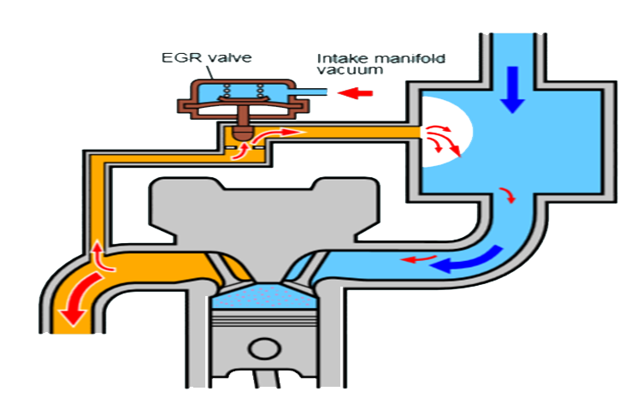In [internal combustion engines](https://en.wikipedia.org/wiki/Internal_combustion_engine), exhaust gas recirculation (EGR) is a nitrogen oxide ([NOx](https://en.wikipedia.org/wiki/NOx" \o "NOx)) emissions reduction technique used in [petrol/gasoline](https://en.wikipedia.org/wiki/Petrol_engine) and [diesel engines](https://en.wikipedia.org/wiki/Diesel_engine). EGR works by re-circulating a portion of an engine's [exhaust gas](https://en.wikipedia.org/wiki/Exhaust_gas) back to the engine [cylinders](https://en.wikipedia.org/wiki/Cylinder_(engine)). This dilutes the O2 in the incoming air stream and provides gases inert to combustion to act as absorbents of combustion heat to reduce peak in-cylinder temperatures. NOx is produced in a narrow band of high cylinder temperatures and pressures.

**EGR system operation**

The exhaust gas, added to the [fuel](https://en.wikipedia.org/wiki/Fuel), oxygen, and combustion products, increases the [specific heat capacity](https://en.wikipedia.org/wiki/Specific_heat_capacity) of the cylinder contents, which lowers the [adiabatic flame temperature](https://en.wikipedia.org/wiki/Adiabatic_flame_temperature).

In a typical automotive [spark-ignited](https://en.wikipedia.org/wiki/Spark_Ignition_Engine) (SI) engine, **5% to 15%** of the exhaust gas is routed back to the intake as EGR. The maximum quantity is limited by the need of the mixture to sustain a continuous flame front during the combustion event; excessive EGR in poorly set up applications can cause misfires and partial burns. In addition, it has been found that nitrogen oxides emission decreases, up to approximately 15% recirculation, at which point there is a tendency for the nitrogen oxides emission to level out. **This indicates that there will be very little advantage in increasing the recirculation of burnt gas beyond about 15%**.

Although EGR does measurably slow combustion, this can largely be compensated for by **advancing spark timing**. The impact of EGR on engine efficiency largely depends on the specific engine design, and sometimes leads to a compromise between efficiency and NOx emissions. A properly operating EGR can theoretically increase the efficiency of gasoline engines via several mechanisms:

* **Reduced throttling losses:** The addition of inert exhaust gas into the intake system means that for a given power output, the [throttle plate](https://en.wikipedia.org/wiki/Throttle_plate) must be opened further, resulting in increased inlet manifold pressure and reduced throttling losses.
* **Reduced heat rejection:** Lowered peak combustion temperatures not only reduce NOx formation, it also reduces the loss of thermal energy to combustion chamber surfaces, leaving more available for conversion to mechanical work during the expansion stroke.
* **Reduced chemical dissociation:** The lower peak temperatures result in more of the released energy remaining as sensible energy near TDC (Top Dead-Center), rather than being bound up (early in the expansion stroke) in the dissociation of combustion products. This effect is minor compared to the first two.

EGR is typically not employed at **high loads** because it would reduce peak power output. This is because it reduces the intake charge density. This can be compensated by other emission control systems in operation with EGR (like catalytic converters, water injection and pre-stratified charge). EGR is also omitted at **idle** (low-speed, zero loads), as well as cold starting operation, because it would cause unstable combustion, resulting in rough idle or start.

Since the EGR system re-circulates a portion of exhaust gases, over time the valve can become clogged with carbon deposits that prevent it from operating properly. Clogged EGR valves can sometimes be cleaned, but replacement is necessary if the valve is faulty.

**Diesel operation**

- In a gasoline engine, this inert exhaust displaces the amount of combustible matter   
 in the cylinder.   
- In a diesel engine, the exhaust gas replaces some of the excess [oxygen](https://en.wikipedia.org/wiki/Oxygen) in the pre-  
 combustion mixture. Since oxygen concentration is decreased by EGR system, this   
 causes the temperature and pressure in chamber to decrease. This causes the   
 **"Ignition Delay Period"** to increase which can lead to hard knock and power loss.   
 Thus, it can affect the engine performance and life expectancy. However, it is very   
 efficient for high concentrations of oxygen (very lean mixtures).

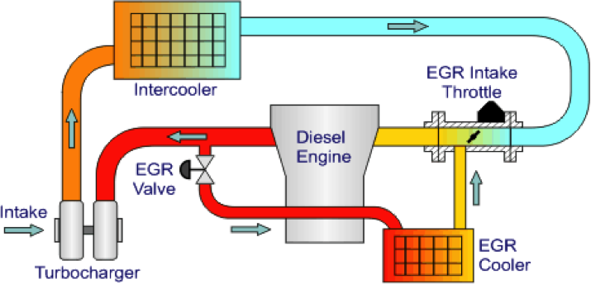- Also, for diesel engines a heat exchanger is place in the path of the exhaust gas to   
 cool them (EGR cooler). Now, on [turbo](https://www.ebay.com/sch/eBay-Motors/6000/i.html?_from=R40&_nkw=turbo) [diesel](http://www.thedieselstop.com/forums/)s, controlling the inlet air charge   
 temperature is important as it directly influences [exhaust](https://www.ebay.com/sch/eBay-Motors/6000/i.html?_from=R40&_nkw=exhaust) [gas](https://www.ebay.com/sch/eBay-Motors/6000/i.html?_from=R40&_nkw=gas) temperature -- and if   
 EGT is too high, it can cause damage to expensive bits downstream -- such as the   
 turbocharger. So to keep the [EGR](https://www.ebay.com/sch/eBay-Motors/6000/i.html?_from=R40&_nkw=egr) from spiking the inlet air charge temp (IACT) too   
 high, the [EGR](https://www.ebay.com/sch/eBay-Motors/6000/i.html?_from=R40&_nkw=egr) gases pass through a [cooler](http://www.thedieselstop.com/forums/) that knocks a bunch of heat out and   
 transfers it to the [coolant](https://www.ebay.com/sch/eBay-Motors/6000/i.html?_from=R40&_nkw=coolant). This drops the EGR [gas](https://www.ebay.com/sch/eBay-Motors/6000/i.html?_from=R40&_nkw=gas) temp from as much as 1000F   
 to [500F](http://www.amazon.com/dp/B007IBHOA8) or lower.

**EGR parts**

1. EGR Valve

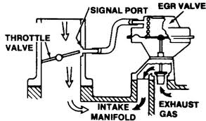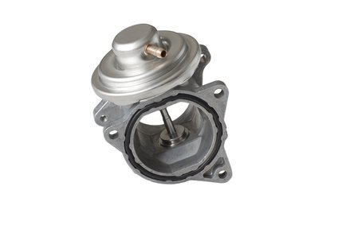The valve is usually used to control the flow of gas using the vacuum formed at intake throttle valve.

1. 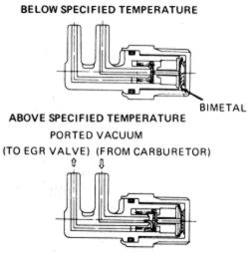Thermo vacuum lock  
   A bimetal that is used to cut off valve operation during cold start

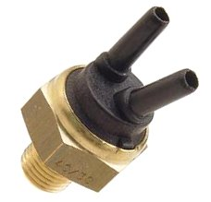

1. Vacuum reservoir

A vacuum canister to provide extra vacuum for hot day operation

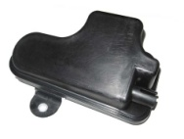

1. Differential flow limiters for response time damping (orifice, restrictions…etc)

**References**

[1] https://en.wikipedia.org/wiki/Exhaust_gas_recirculation

[2] https://www.cambustion.com/products/egr

[3] https://www.micksgarage.com/blog/egr-valve/

[4] http://www.thedieselstop.com/forums/f23/egr-cooler-what-does-do-145001/